Web Filter
The department has set the web filter in the school to require searches to have SafeSearch turned on. This must be done manually on every computer and web browser you use. When you try to search for anything, the following message should appear:
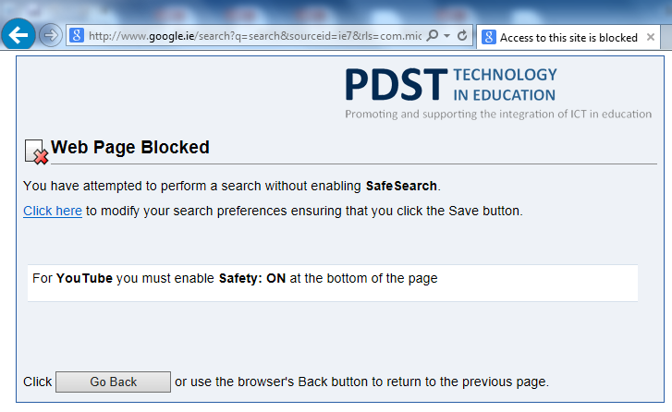
To fix it, click Click here, modify the settings to enable filtering and click Save.
On Google it looks like this:
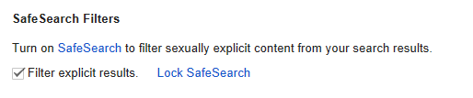

On Bing this:
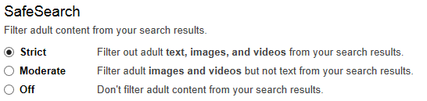

And for YouTube, the setting is at the bottom of the page and looks like this:
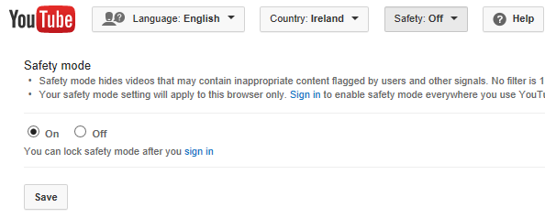
This sometimes doesn’t save properly the first time and needs to be set twice.

If you’ve any other problems, please let me know using the IT Helpdesk icon on your desktop!

